ANOKHA PROJECT DOCUMENTATION

AMRITA CANTEEN APPLICATION

**TEAM DESCRIPTION:**

|  |  |  |
| --- | --- | --- |
| NAME | ROLL NO. | DEPARTMENT |
| Chandana Daggupati | CB.EN.U4CSE20116 | CSE |
| Dheepak Raaj R | CB.EN.U4CSE20119 | CSE |
| Jai Vardhan N | CB.EN.U4CSE20126 | CSE |
| Jegadit S Saravanan | CB.EN.U4CSE20127 | CSE |

**PROJECT MENTOR:**

**Dr. Anbazhagan Mahadevan**

Assistant Professor,

Amrita School of Computing,

Amrita Vishwa Vidyapeetham

Coimbatore.

CONTENTS

* PROBLEM STATEMENT
* INTRODUCTION
* ABSTRACT
* OBJECTIVE
* IDEA
* PROPOSED SOLUTIONS
* BENEFITS AND LIMITATIONS
* ADDITIONAL DETAILS

**PROBLEM STATEMENT:**

A real-time problem faced by both students and the faculty members when they are willing to have their meal in a canteen; But due to the lack of knowledge of the current menu being followed in the canteen and the crowd in the canteen it creates an un-avoidable waste of time and un-necessary confusions, when the ordered item is unavailable. Solving this problem using an application and deploying it will make the students and faculty members to take informed decision about where and what to eat.

**INTRODUCTION:**

This canteen application uses cameras to get the information on the menu and crowd and feeds them to deep learning algorithms to accurately display the required information about the canteen. The primary challenge is to provide real-time information to users about the current menu options and the current crowd in the canteen to help them make decision to choose a canteen.

**ABSTRACT:**

This project aims to address the real-time problem faced by students and faculty members when choosing to dine in a canteen. The lack of knowledge of the current menu and crowd in the canteen can lead to unnecessary waste of time and confusion. To solve this problem, an application will be developed that utilizes deep learning algorithms and live camera feeds to provide real-time information about the available menu and the crowd in the canteen. The system will process the incoming data in real-time and generate relevant insights and accurate predictions. The resulting application will improve the dining experience for all users by providing a comprehensive list of menu items and displaying the current level of congestion in the canteen, helping users make informed decisions about where and what to eat.

**OBJECTIVE:**

A real-time application will be developed to address the problem mentioned, utilizing live camera feeds as input data for deep learning algorithms. The system will process the incoming data in real time and leverage the power of deep learning to generate relevant insights and make accurate predictions. The application will involve the integration of advanced computer vision techniques and deep learning algorithms. The resulting system will provide timely and accurate information for decision-making purposes.

**IDEA:**

The idea of this app is to use deep learning algorithms to provide users with real-time information about the available menu and the crowd in the canteen, improving the dining experience for all the students and faculty members. Using the existing cameras, how we can estimate the crowd is, by giving a training set as Empty tables, chairs with bags, existing people in the tables etc, and will train the model to predict two classes – (let’s say) Table empty, Table full. Model will be trained and Based on this test data which is nothing but the images captured by camera, for example an empty table - it will be classified as 'Table Empty'. This is the idea of project and we use neural networks here because this case is non-linear, and we will be needing activation functions.

**PROPOSED SOLUTIONS:**

Upon opening the app, users will see a comprehensive list of menu items available. By leveraging advanced deep learning algorithms, the app can automatically detect any modifications or updates made to the menu through camera feeds, ensuring that users always have access to the latest menu information.

The app utilizes cutting-edge deep learning algorithms to provide users with a real-time, up-to-date list of menu items as soon as they launch it. By analysing camera footage, the app is able to quickly identify any changes or additions to the menu, making sure that users are always aware of the most current offerings.

In addition to a comprehensive menu, the app also displays the current level of congestion in the canteen. Through the use of advanced deep learning algorithms and strategically placed cameras, the app can quickly analyse real-time data to provide users with an accurate assessment of how busy the canteen is at any given moment. Armed with this information, users can make informed decisions about when to visit the canteen to avoid long wait times.

**BENEFITS AND LIMITATIONS:**

**BENEFITS:**

**Improved User Experience:**

The application will help students and faculty members make informed decisions about where and what to eat, which will reduce confusion and wasted time.

**Real-Time Information:**

The use of live camera feeds and deep learning algorithms will provide real-time information about the current menu and the crowd in the canteen, which will help users make timely decisions.

**Reduced Congestion:**

The system will display the current level of congestion in the canteen, which will help users avoid overcrowded areas and reduce congestion.

**Increased Efficiency:**

The system will process the incoming data in real-time and generate relevant insights and accurate predictions, which will help canteen staff to manage resources more efficiently.

**LIMITATIONS:**

**Technical Limitations:**

The success of the application will depend on the accuracy of the deep learning algorithms used and the quality of the live camera feeds. Any technical issues with the system may affect its accuracy and usefulness.

**Privacy Concerns:**

The use of live camera feeds may raise privacy concerns for some users, and it will be essential to ensure that their privacy is protected.

**Accessibility:**

The application may not be accessible to all users, particularly those who do not have access to smartphones or other mobile devices. Additionally, users who are not familiar with technology may face difficulties in using the system.

**ADDITIONAL DETAILS: [APP INTERFACE]**

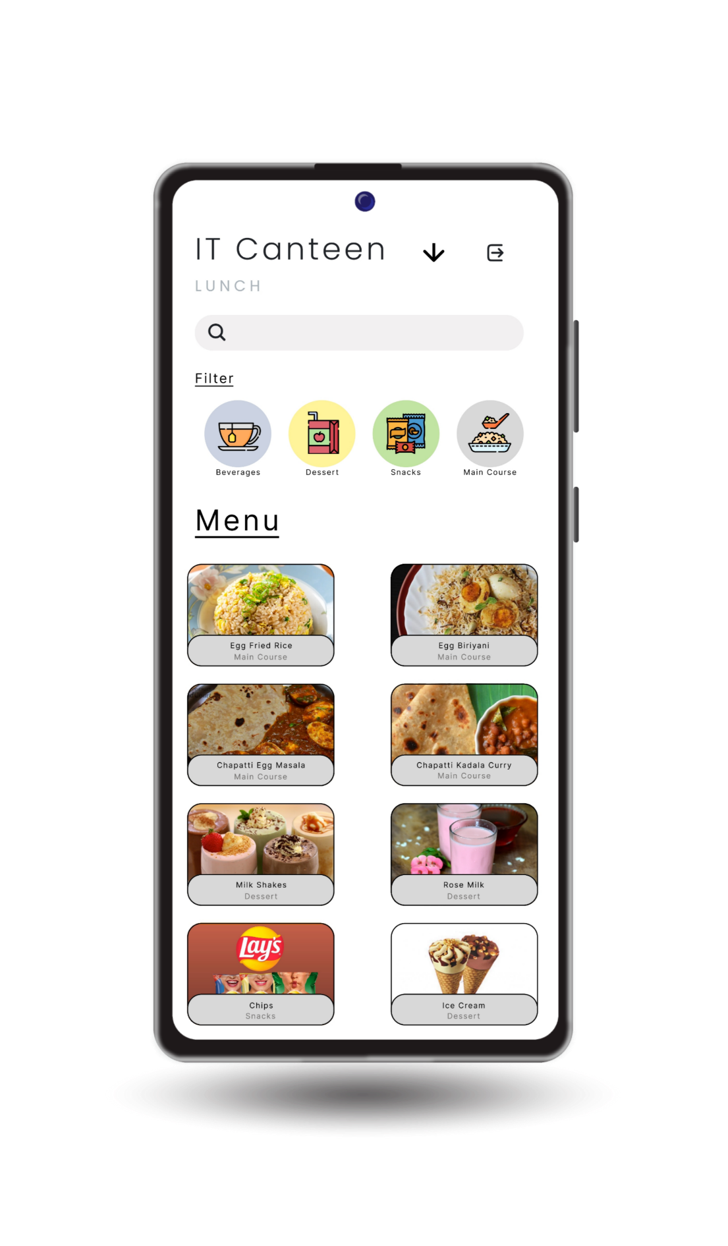

**DESCRIPTION:**

This is a sample ‘App interface’ which display’s the information of the food items present in the menu. And also lets us filter out the choice of food and check for its availability.

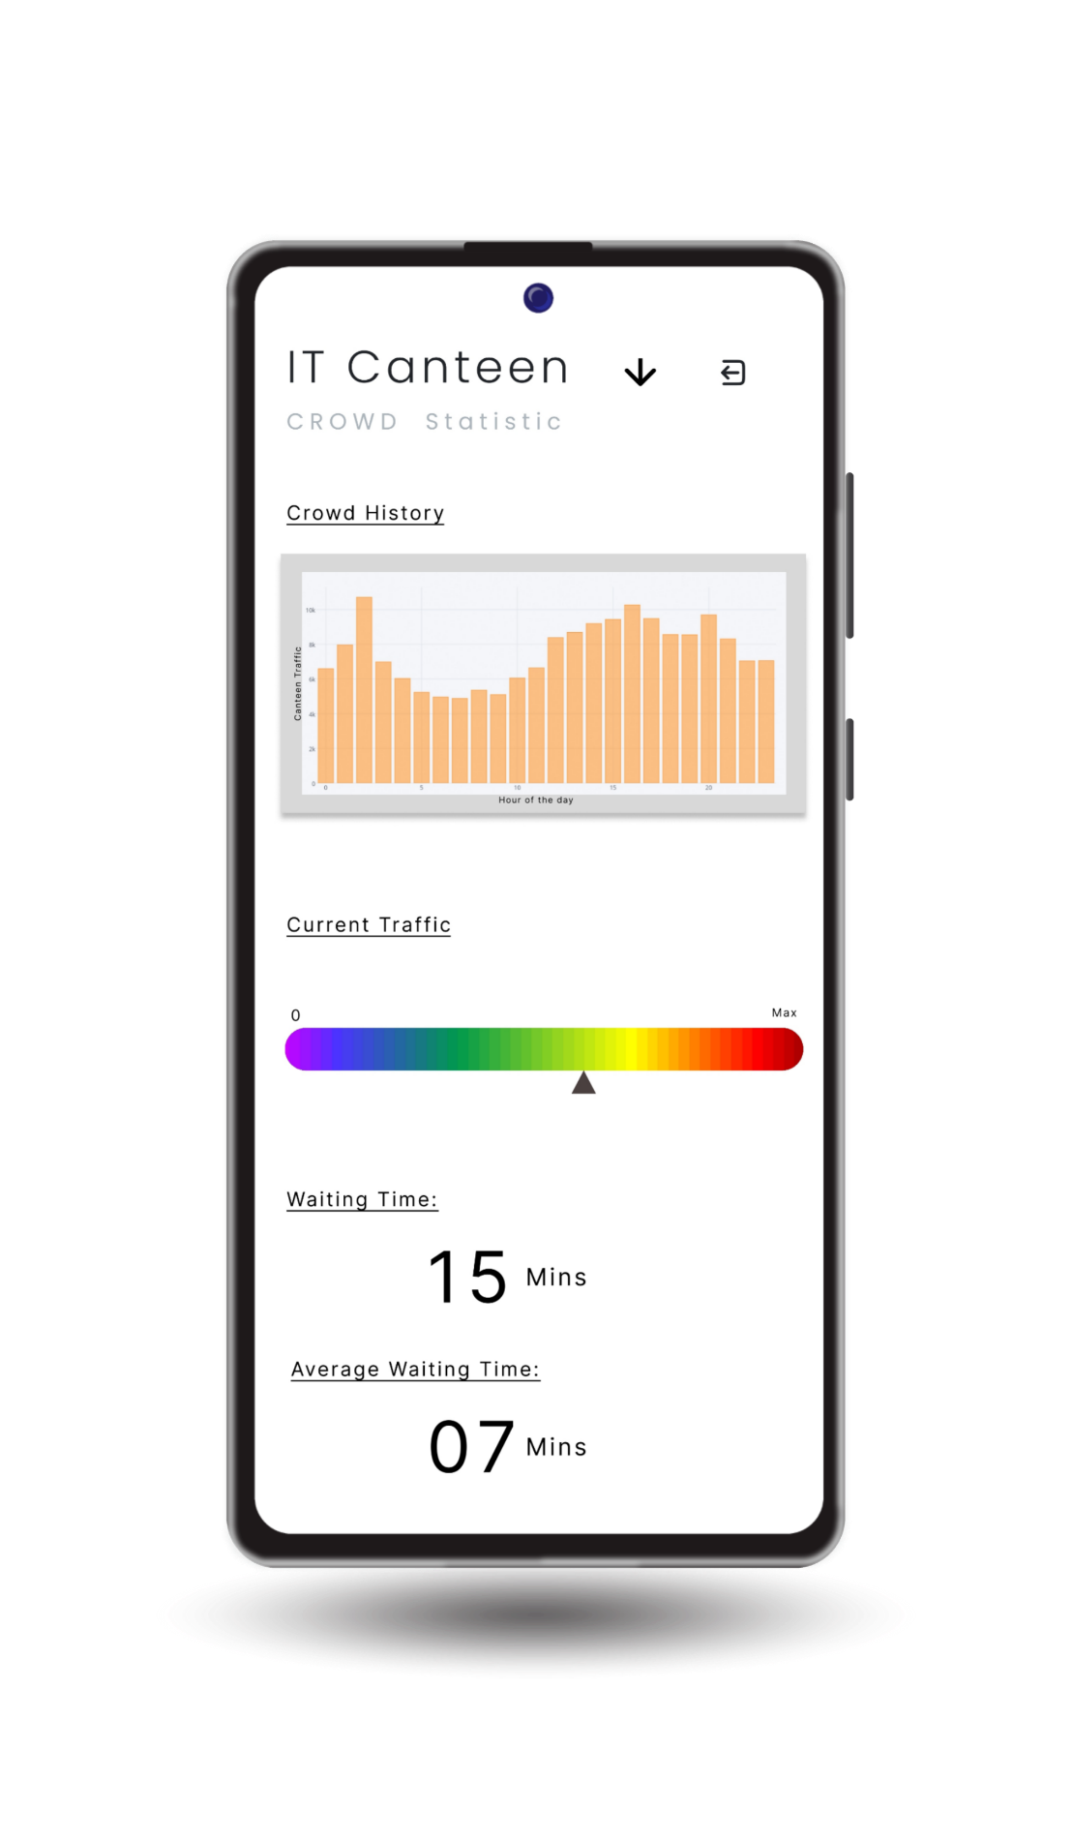

**DESCRIPTION:**

This is a sample ‘App interface’ which display’s the information’s like crowd history, crowd statistic, waiting time and avg. waiting time. These information’s can be used to choose between the canteens based on both the crowd statistic and the waiting time.